**Installation Document**

**Prerequisite :**

Anaconda – Jupyter or Python

**Download the source Code:**

INFO5082_Group7.zip

Unzip the above folder

Folder consists of below files:

1. EDA.ipynb file 🡪 This file has code for EDA
2. Model.ipynb file 🡪 This file has code for Model
3. Requiments.txt file 🡪 This file has required packages

**Running the code:**

Run the .ipynb or .py file

**Create a virtual environment:**

How to create virtual environment to run python code?

Please follow the below steps to create a virtual environment in python

<https://www.geeksforgeeks.org/using-jupyter-notebook-in-virtual-environment/>

**Install required packages**

In the command line type "pip install requirements.txt" for installing required versions needed to run the code.

 **Or**

You can download packages before importing modules in Jupyter. This should be the first cell in the code.

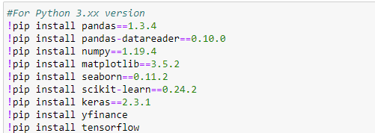

**Results:**

Trained models are saved in the folder with name "**Trained models**". It contains the models saved after training 50 epochs.

Log files with loss degradation are saved in the "**logs**" directory for each ticker respectively.